Task 13 – Evidence Report
Teardown and Reset Process for the DSYS601 Observability Lab
Student | Kabir Singh Thukrai
Student ID | 99281336
Course | BCIS309 – Work Integrated Learning Project
Task | Task 13 – Formal teardown/reset (decommission) process so the environment can be reliably rebuilt between cohorts
Scripts | teardown-cluster.sh, verify-lab.sh, reset-lab.sh and docs/teardown-reset.md
Repository | https://github.com/kat0870/dsys601-k8s-observability-lab
Date | 30 September 2026

1. What this task was about
The brief asks for a formal teardown and reset process, so the lab can be reliably rebuilt between cohorts. In practice that means a safe way to wipe the lab, a quick way to bring it back, a way to check it is healthy, and a written checklist a tutor can follow.

2. What the old teardown did
The old teardown-cluster.sh was one line: kind delete cluster. I ran it and checked what was left behind (Figure 1).
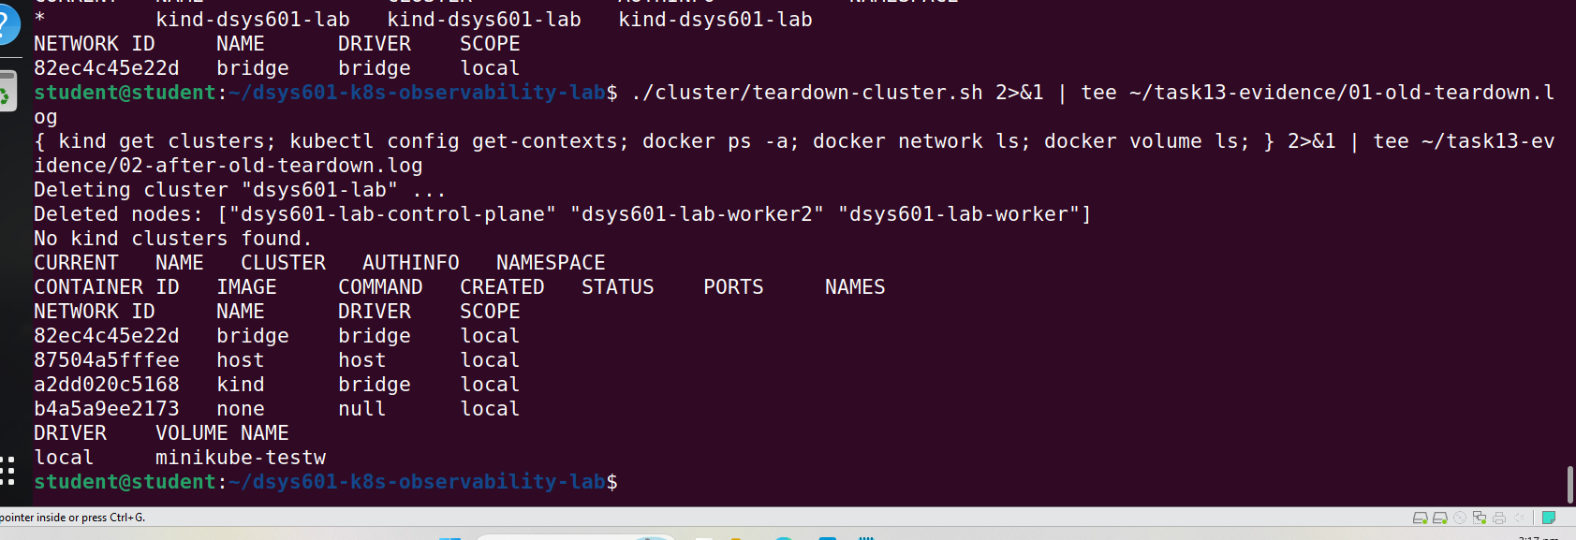
Figure 1. State of the machine after the old teardown
Item | After old teardown
Cluster, node containers and node storage | Removed
kubectl context | Removed
kind Docker network | Kept (Kind reuses it, so this is fine)
minikube-testw volume | Left behind (leftover from Task 2)

So the clean-up itself was fine. The problems were that it deleted straight away with no confirmation, it did not check that anything was actually removed, and it failed if there was no cluster.

3. A safer teardown script
I rewrote teardown-cluster.sh. It now asks you to type the cluster name before deleting, does nothing if there is no cluster, and checks afterwards that the node containers and kubectl context are gone. A --yes option skips the prompt so the reset script can use it.
With no cluster running it just said there was nothing to delete (Figure 2).
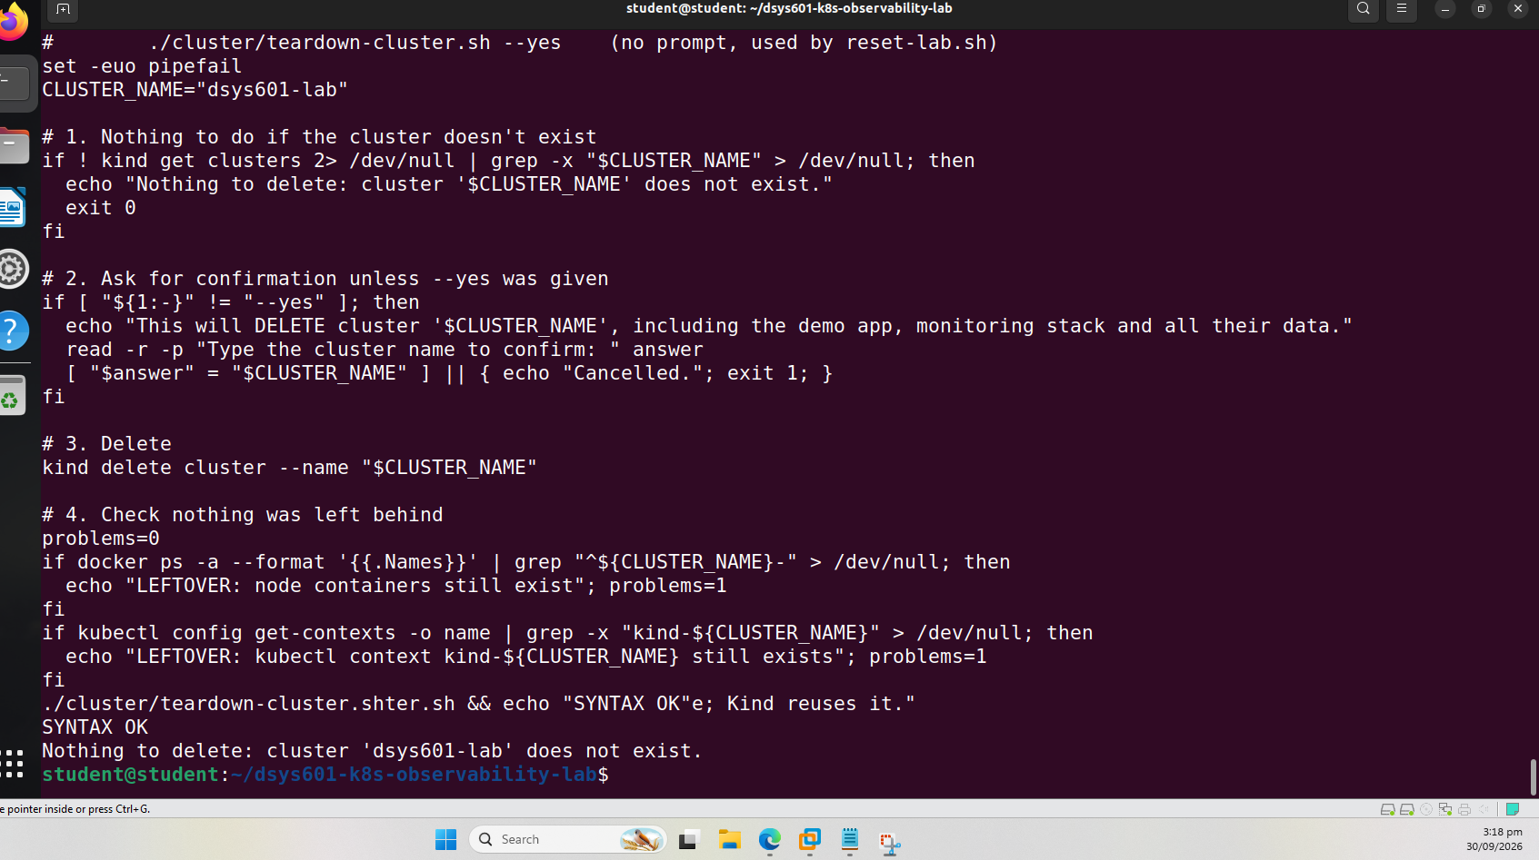
Figure 2. New teardown script with no cluster: nothing to delete

4. A health check script
I added verify-lab.sh. It runs 11 checks and prints PASS or FAIL for each, then LAB READY or LAB NOT READY. It checks the nodes, system pods, demo app, Prometheus, Alertmanager, node-exporter, the Helm chart version, and that the DSYS601 alert rules and dashboard are loaded.
A bug found by testing
I first ran it with no cluster, expecting every check to fail. One check said PASS instead. It looked for pods that were not Running, and with no cluster it found none. I changed it so kubectl has to return pods before it can pass. After that all 11 checks failed correctly (Figure 3).
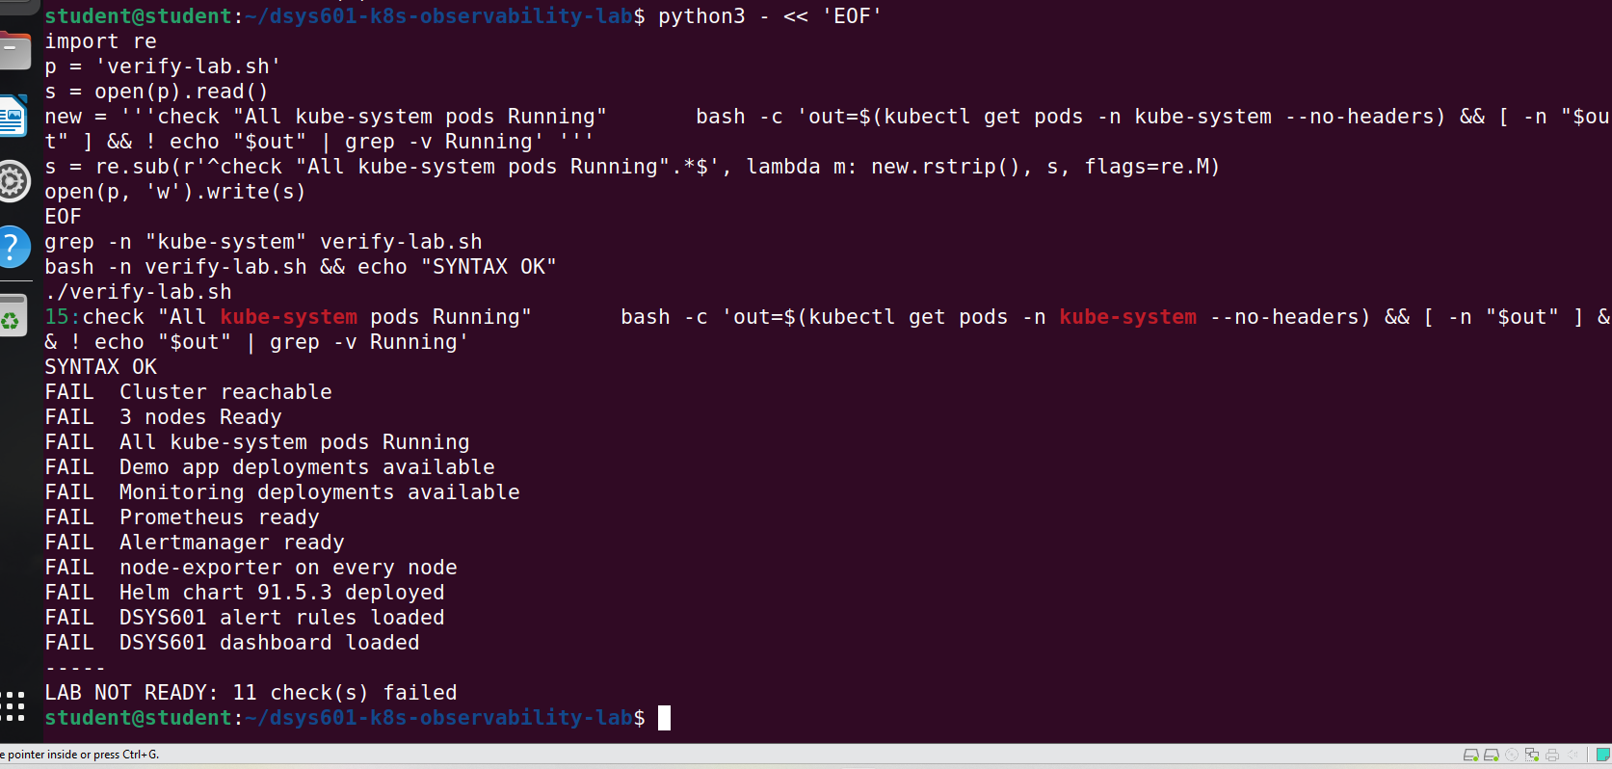
Figure 3. All 11 checks fail with no cluster

5. One-command reset
reset-lab.sh does the whole reset in five steps: teardown, build the cluster, deploy the demo app, install monitoring, and run the health check. It asks you to type RESET first, warns if the repo has uncommitted changes, stops if .env is missing, and prints how long it took.
./reset-lab.sh
I committed the scripts before testing, so the version I tested is the one on GitHub. The first run built the lab from nothing and all 11 checks passed in 1 min 48 s (Figure 4).
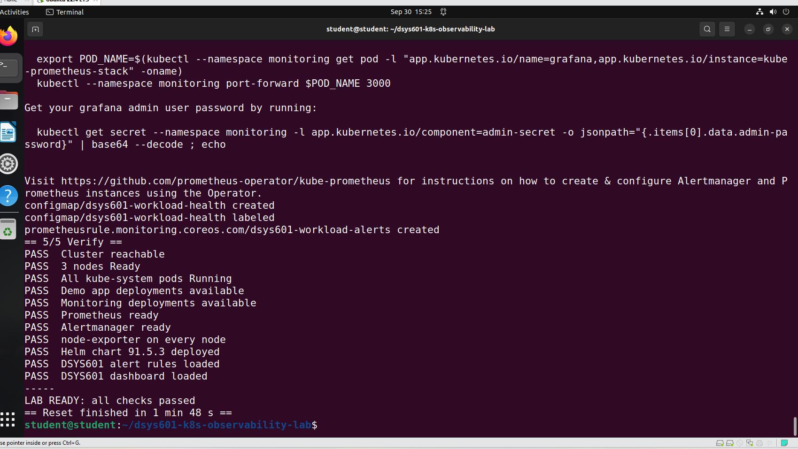
Figure 4. First reset: LAB READY in 1 min 48 s

6. Resetting a used lab
The real case between cohorts is a lab that students have used. To simulate that, I created a student namespace with a pod, and broke the demo app by scaling the frontend to 0 (Figure 5).
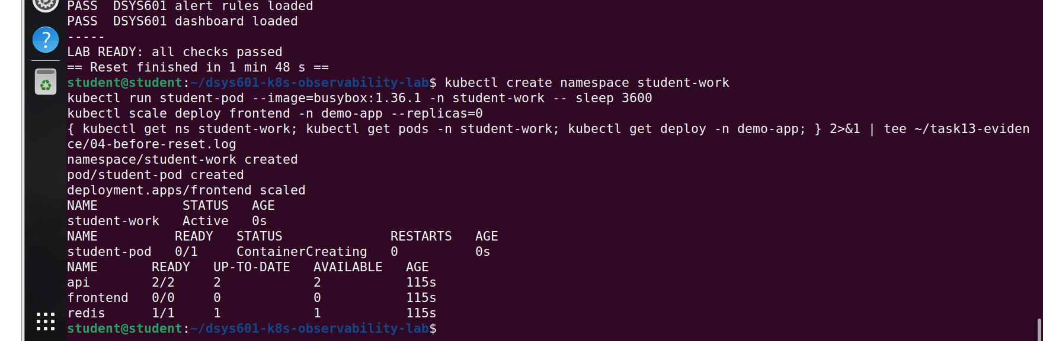
Figure 5. The lab after simulated student use
Then I ran the reset again. All 11 checks passed in 1 min 47 s (Figure 6).
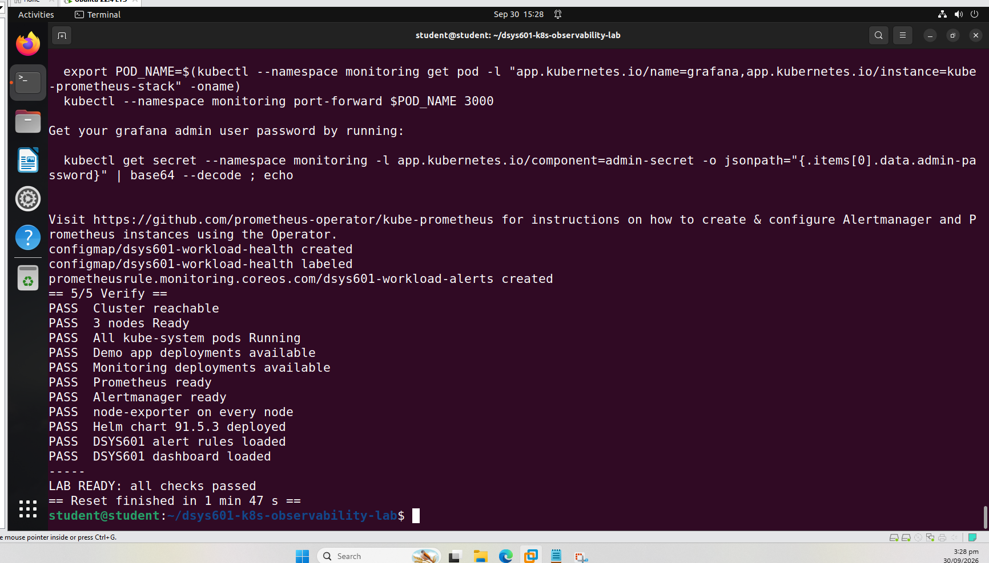
Figure 6. Reset of the used lab: LAB READY in 1 min 47 s
The teardown reported CLEAN, the student namespace was gone, and the frontend was back to 2/2 (Figure 7).
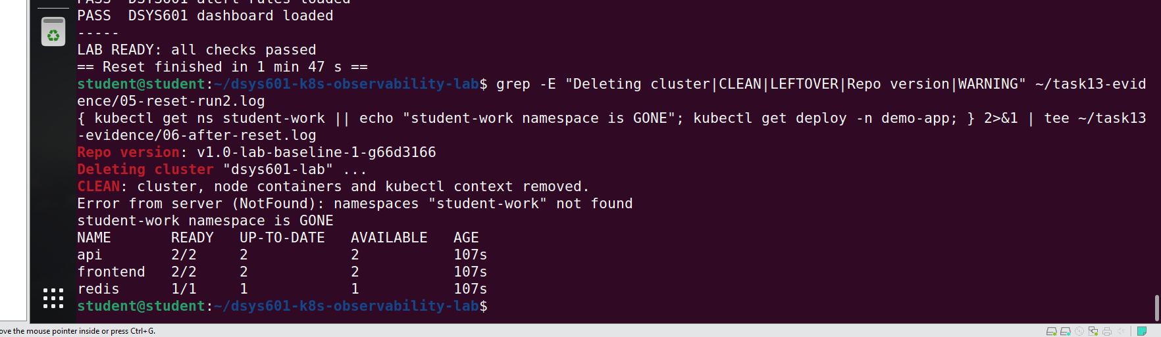
Figure 7. Teardown CLEAN, student work gone, frontend restored
Item | Before reset | After reset
student-work namespace | Active | Gone
student-pod | Running | Gone
frontend | 0/0 | 2/2
Health check | – | 11/11 PASS

7. Safety test
I ran the teardown and typed "no" at the prompt. It said Cancelled and the cluster was still there (Figure 8), so a tutor cannot wipe the lab by accident.
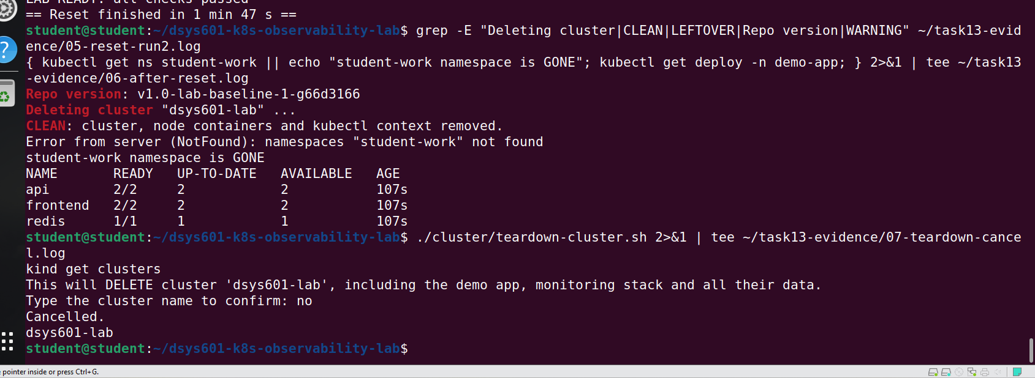
Figure 8. Teardown cancelled at the safety prompt

8. Cleaning up old leftovers
I removed three leftovers from earlier tasks: the minikube-testw volume, the Task 12 test folder (which also had a copy of the password file), and an old config file. Only the three volumes for the current cluster remain (Figure 9).
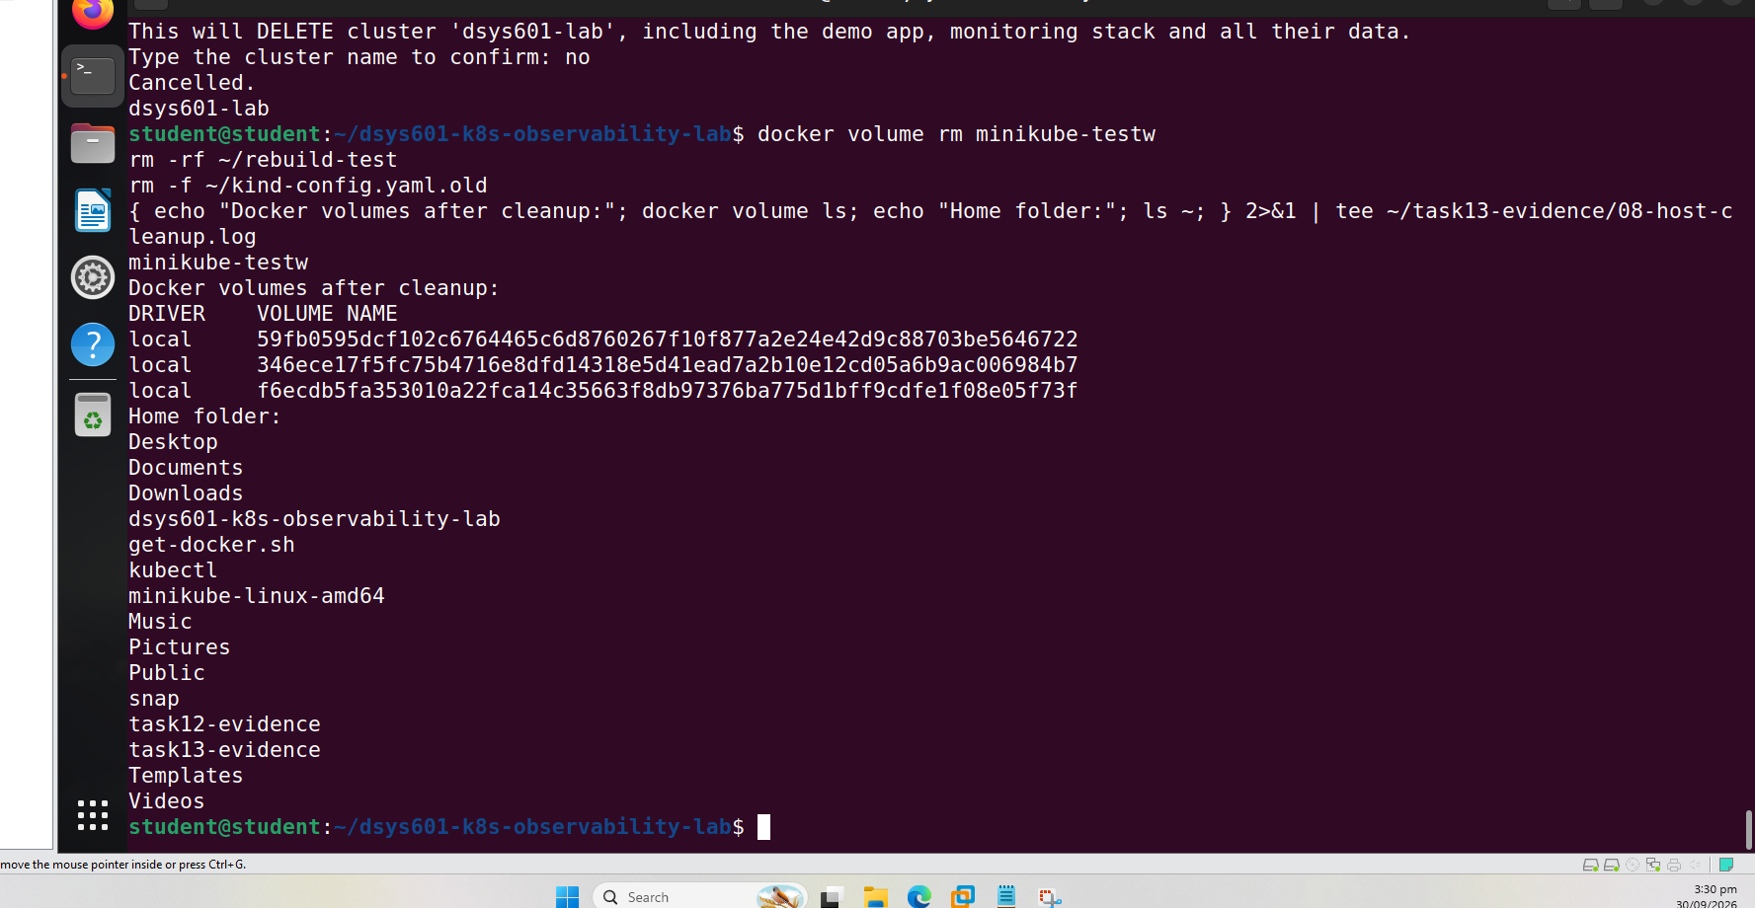
Figure 9. Docker volumes and home folder after the clean-up

9. The procedure document
I wrote docs/teardown-reset.md and linked it from the README. It lists what a reset removes and keeps, what to check before starting, how to run it, what to check after, and has a table to record each reset (Figure 10).
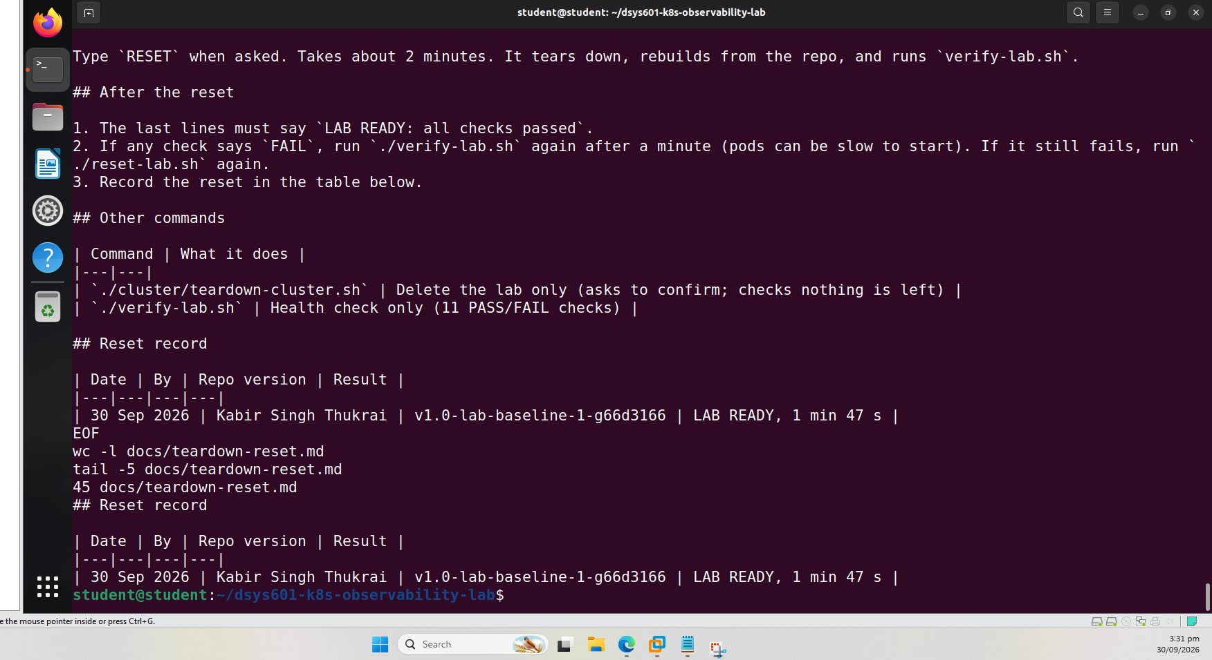
Figure 10. The reset procedure document

10. Where this leaves Task 13
Brief requirement | Covered by
Formal process | docs/teardown-reset.md checklist with a reset record
Safe teardown | Confirmation prompt, nothing-to-delete check, leftover check
Reliable rebuild between cohorts | reset-lab.sh tested on a used lab: 11/11 checks in under 2 minutes
Proof the lab is healthy | verify-lab.sh (11 checks)

The work is in two commits and tagged v1.1-reset-process (Figure 11).
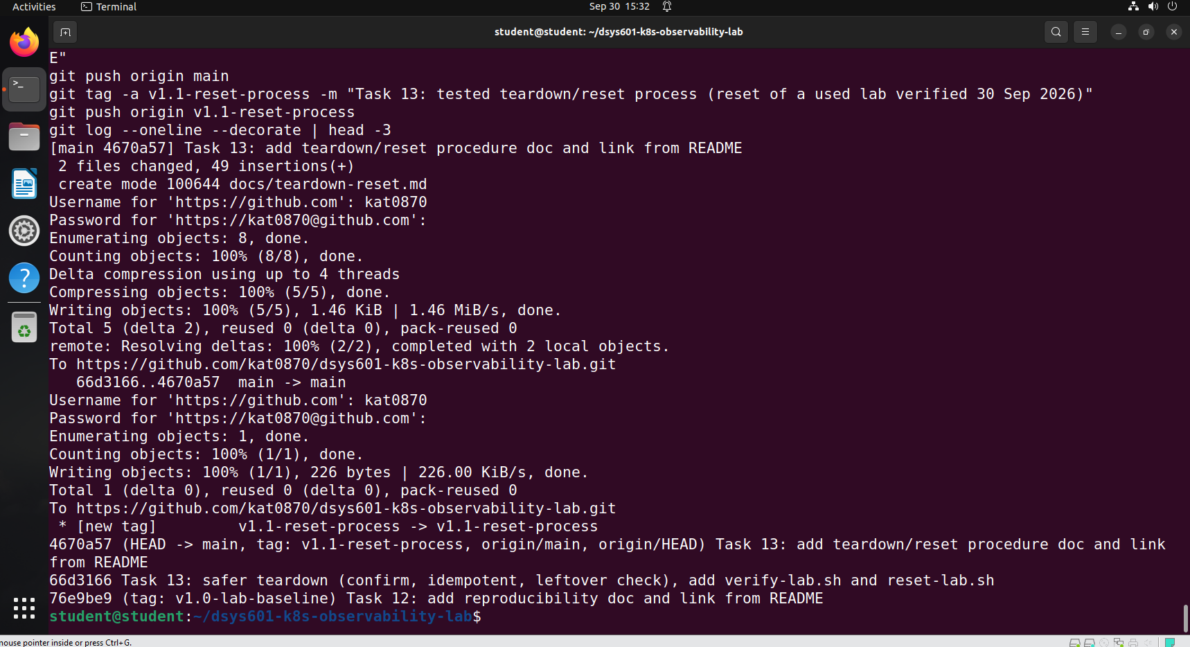
Figure 11. Task 13 commits and tag pushed to GitHub
The reset time includes the few seconds spent typing RESET. The procedure covers resetting between cohorts; a short section on fully retiring the lab from a machine could be added later. Next is Task 14, handing over the standing lab environment.
Repository: https://github.com/kat0870/dsys601-k8s-observability-lab

